CSS Responsive Design

1. Box (80% width, max 600px)
Code:
.box {
width: 80%;
max-width: 600px;
height: 150px;
background-color: steelblue;
margin: auto;
}
Explanation:
The box takes 80% of the screen width but will not exceed 600px. It remains responsive on smaller screens and stops growing on larger screens.

2. Paragraph (1.5rem)
Code:
.text {
font-size: 1.5rem;
}
Explanation:
rem is based on the root font size (usually 16px). 1.5rem equals 24px. It adapts if the user changes browser settings, making it accessible.

3. Heading using vw
Code:
.title {
font-size: 5vw;
}
Explanation:
vw is based on viewport width. Text scales depending on screen size, making it responsive across devices.

4. Media Query (below 768px)
Code:
@media (max-width: 768px) {
body {
background-color: lightcoral;
}
}
Explanation:
Media queries allow applying styles based on screen size. Here, the background changes for smaller devices like tablets and mobiles.
Final code:
<!DOCTYPE html>
<html lang="en">
<head>
<meta charset="UTF-8">
<meta name="viewport" content="width=device-width, initial-scale=1.0">
<title> Css Responsive</title>

<style>
body {
margin: 0;
font-family: 'Segoe UI', Tahoma, sans-serif;
background: linear-gradient(135deg, #74ebd5, #ACB6E5);
text-align: center;
color: #333;
}
h1 {
font-size: 5vw;
margin-top: 30px;
color: #222;
letter-spacing: 2px;
}
.container {
padding: 20px;
}
#box {
width: 80%;
max-width: 600px;
height: 200px;
margin: 40px auto;
background: linear-gradient(135deg, #667eea, #764ba2);
display: flex;
align-items: center;
justify-content: center;
font-size: 1.3rem;
color: white;
border-radius: 20px;
box-shadow: 0 10px 25px rgba(0,0,0,0.2);
}

.text {
font-size: 1.5rem;
max-width: 700px;
margin: auto;
padding: 20px;
line-height: 1.6;
background: white;
border-radius: 15px;
box-shadow: 0 5px 15px rgba(0,0,0,0.1);
}
@media (max-width: 768px) {
body {
background: linear-gradient(135deg, #ff9a9e, #fad0c4);
}

#box {
background: linear-gradient(135deg, #ff6a00, #ee0979);
}

.text {
font-size: 1.2rem;
}
}
</style>
</head>

<body>

<div class="container">
<h1>CSS Task 13</h1>

<div id="box">
Responsive Box
</div>

<p class="text">
This paragraph uses <strong>1.5rem</strong>. It stays consistent across devices
and adjusts if the root font size changes.
</div>

</body>
</html>
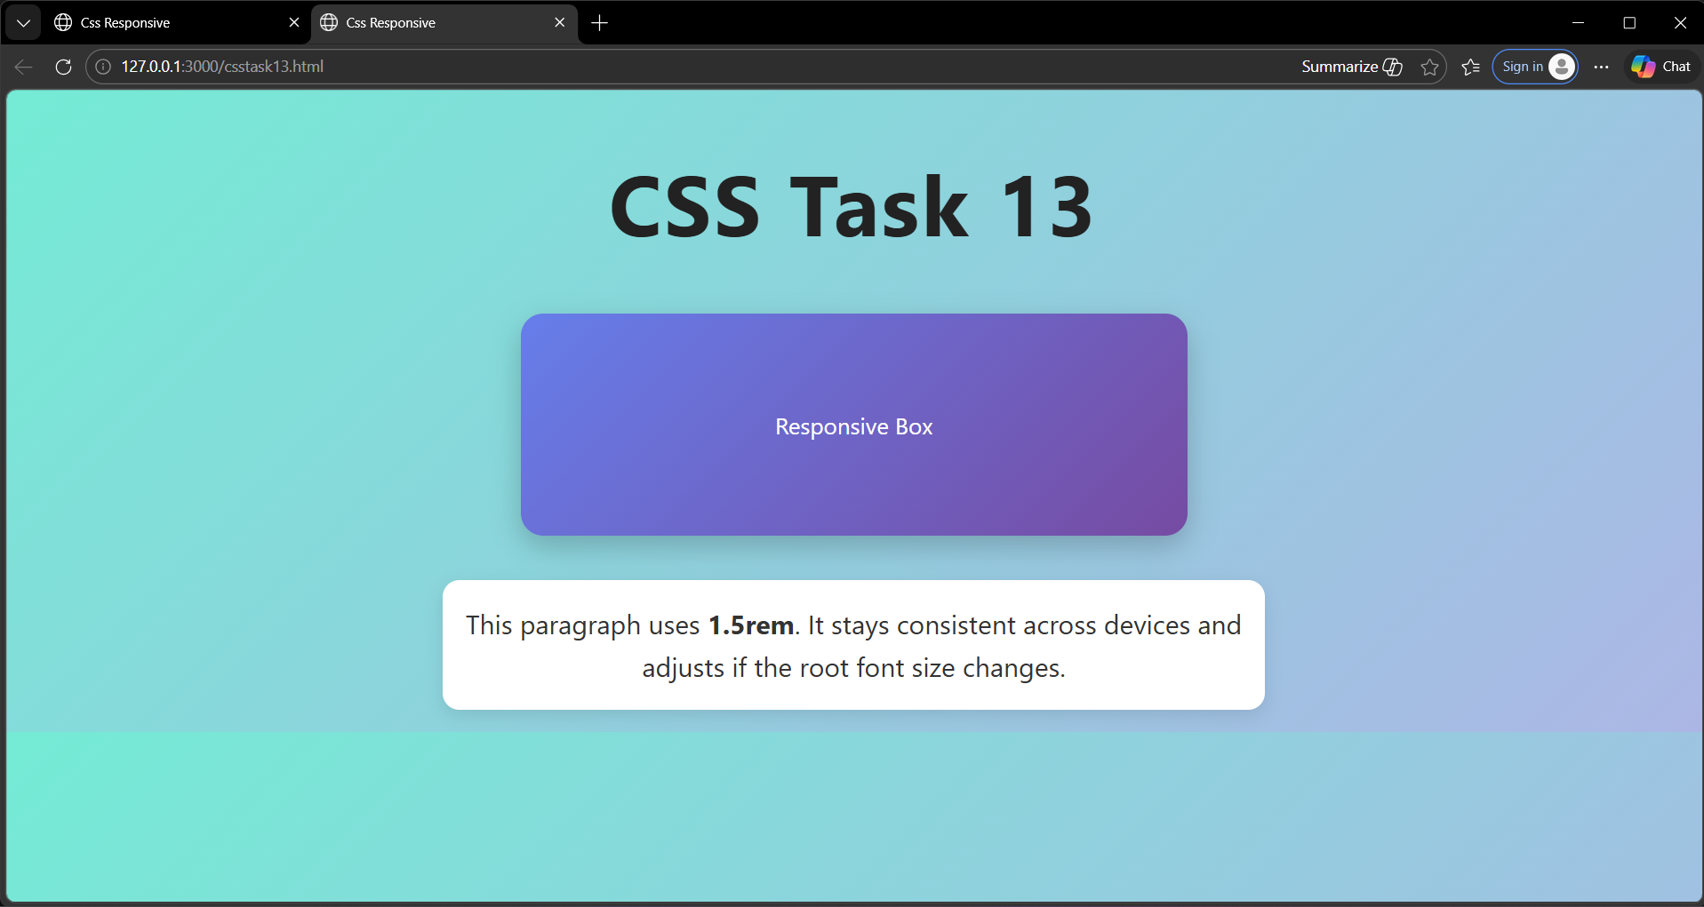
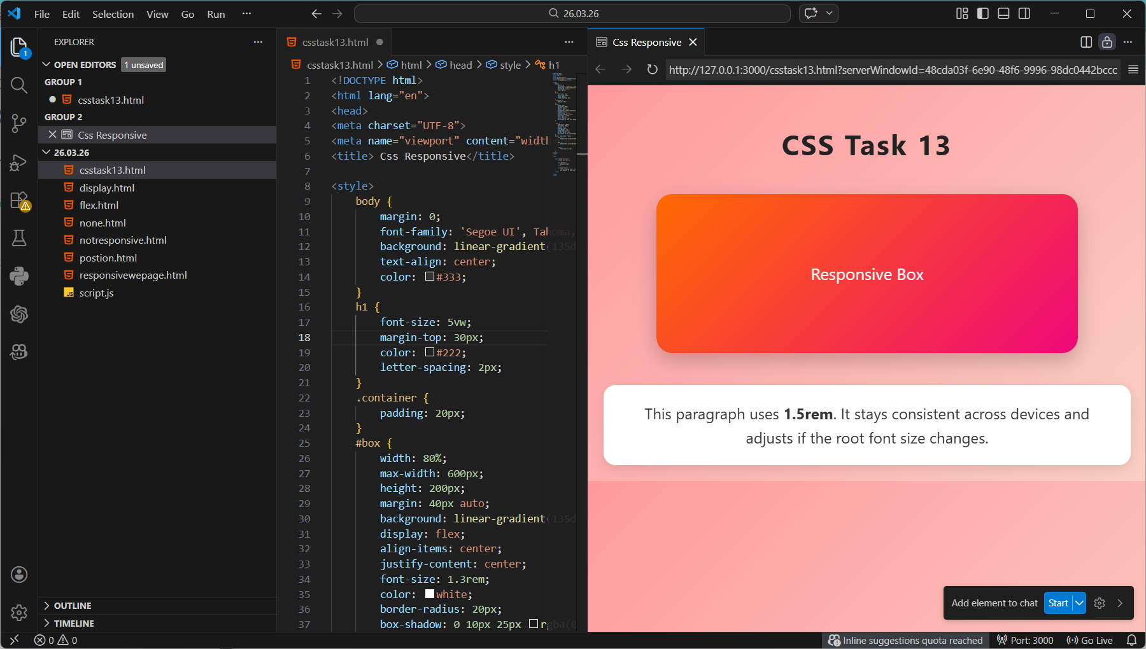
Output:

